LAKE ARTHUR
MUNICIPAL SCHOOLS

2025-2026 Student
Culture Guide



Dear Students and Parents/Guardians,

Welcome to a new school year at Lake Arthur Municipal Schools! As we embark on this exciting journey together, we look forward to creating lasting memories and achieving great milestones. The experiences you gain here will be cherished for a lifetime, shaping your growth and learning in profound ways.

Lake Arthur Municipal Schools is proud to offer a vibrant environment where students can thrive academically, socially, and personally. We are known for having the best students, parents, staff, and community in the Pecos Valley; one dedicated to working toward continuous improvement. Our community is known for its dedication to excellence, and we are excited to have you as part of our Panther family. With your support and active participation, we will continue to uphold the legacy of pride and accomplishment that defines our schools.

At our school, we believe that education is more than just academics; it's about fostering a holistic growth environment where students can thrive and excel. Our culture guide is designed to guide and support students in developing essential skills and values that will prepare them for success in school and beyond. We encourage you to embrace this opportunity, strive for excellence, and take full advantage of the activities and opportunities available. We look forward to a successful and fulfilling school year, working together with parents, students, and the entire school community to achieve our shared goals. Together, let's make this school year unforgettable and continue to build on the achievements of Lake Arthur Municipal Schools.

The administration and staff of Lake Arthur Municipal Schools welcome you to the
2025-2026 school year.

Sincerely,

Elisa Begueria Karol Rodriguez

Elisa Begueria, Superintendent Karol Rodriguez, Principal

Staff Directory
Elisa Begueria Superintendent elisa.begueria@la-panthers.org
Karol Rodriguez Principal karol.rodriguez@la-panthers.org
DeeDee Dalton Business Manager dee.dalton@la-panthers.org
Isis Lopez Cortez Administrative Assistant isis.cortez@la-panthers.org
Audrey Chambers Bookkeeper audrey.chambers@la-panthers.org
Diana Rivera Technology Coordinator diana.rivera@la-panthers.org
Amy Ellis AD/Facilities Manager amy.ellis@la-panthers.org
Paul Lessard Special Education Director paul.lessard@la-panthers.org
Delia Coronado Community Liaison delia.coronado@la-panthers.org
Brandie Medrano SEL Coach brandie.medrano@la-panthers.org
Denise Woody Instructional Consultant denise.woody@la-panthers.org
Socorro Ramirez NM Pre-K Teacher socorro.ramirez@la-panthers.org
Brittany Mason NM Pre-K EA brittany.mason@la-panthers.org
Rosa Mijares Kinder Teacher rosa.mijares@la-panthers.org
Dulce Saenz 1st Grade Teacher dulce.saenz@la-panthers.org
Ginger Wood 2nd Grade Teacher ginger.wood@la-panthers.org
D’Mar Ortega 3rd Grade Teacher d’mar.ortega@la-panthers.org
Shayna Miller 4th/5th ELA Teacher shayna.miller@la-panthers.org
Carla Lopez 4th/5th Math Teacher carla.lopez @la-panthers.org
Jason Walker MS Science jason.walker@la-panthers.org
Raelyn Fields Secondary English/ELA raelyn.fields@la-panthers.org
Sarah Farley Secondary ELA/Art sarah.farley@la-panthers.org
Stefeni Becerra Secondary Social Studies/DECA stefeni.becerra@la-panthers.org
Cheree Lynch Secondary Online cheree.lynch@la-panthers.org
Jeff Davis Secondary Math jeff.davis@la-panthers.org
Adriana Barnes Secondary Math adriana.barnes@la-panthers.org
Naira Stearnes Secondary Science naira.stearnes@la-panthers.org
Tomee England Welding Teacher tomee.england@la-panther.org
Patricia Soto Bilingual Teacher patricia.soto@la-panthers.org
Cynthia Flores EA cynthia.flores@la-panthers.org
Christina McDonald EA christina.mcdonald@la-panthers.org
Sheri Casto EA sheri.casto@la-panthers.org
Merced Tarango Cafeteria merced.tarango@la-panthers.org
Cecilia Rangel Cafeteria cecilia.rangel@la-panthers.org
Emilia Gutierrez Custodian emilia.gutierrez@la-panthers.org
Lupita Sierra Custodian lupita.sierra@la-panthers.org
Delma Jurado Bus Driver delma.jurado@la-panthers.org

Vision:
“Ready for Life, College or Career.”

Mission:
“Inspire, Challenge, and Support our Students to Achieve Their Full Potential.”

Core Values:
Community, Safety, Perseverance, Integrity, Compassion and Respect

The Portrait of Lake Arthur Graduate: 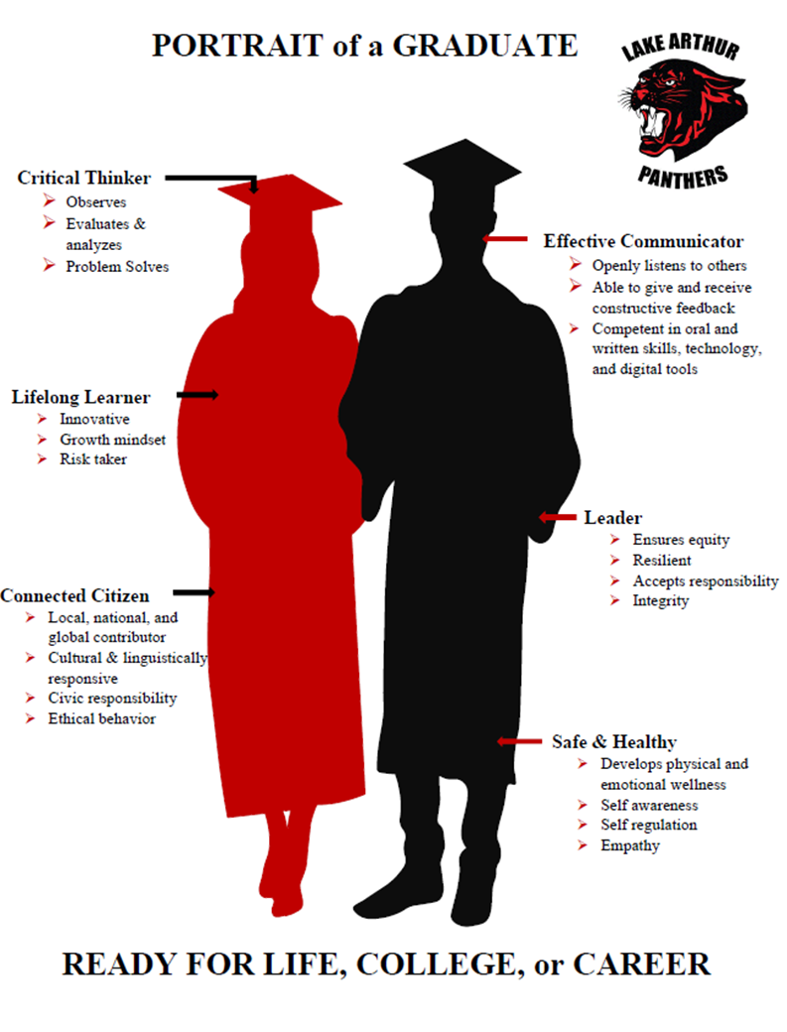
Student Values Based on the Portrait of a Graduate

Critical Thinker
As a critical thinker, you are expected to observe, evaluate, and analyze information with an open mind and a desire to understand multiple perspectives. You will problem-solve by asking thoughtful questions and using evidence to make well-reasoned decisions. By thinking critically, you will be able to navigate complex situations both inside and outside the classroom.
Effective Communicator Effective communication is key to success. You are expected to express your thoughts clearly and respectfully, orally, written, and through technology. Listening actively to others, understanding their viewpoints, and engaging in meaningful discussions will help you collaborate and build strong relationships. Additionally, giving and receiving constructive feedback will empower you to share your ideas and influence your school positively.
Lifelong Learner
Learning doesn’t end with graduation; it's a lifelong journey. You are encouraged to stay curious, seek new knowledge, and embrace opportunities for growth with an innovative and risk-taking attitude. By maintaining a growth mindset, you will continually develop new skills, adapt to change, and remain relevant in an ever-evolving world. This mindset will help you achieve personal and professional fulfillment throughout your life.

Connected Citizen
As a connected citizen, you are expected to understand and appreciate the diverse world around you. Engage in your community, respect different cultures, and contribute positively to society with ethical behavior. By building connections with others and participating in civic activities, you will foster a sense of belonging and responsibility, helping to create a more inclusive and just world.

Leader
Leadership is about inspiring and guiding others towards a common goal. You are expected to demonstrate integrity, take initiative, and motivate your peers with a focus on equity and responsibility. By setting a positive example, showing resilience, and making ethical decisions, you will earn the trust and respect of others. Your leadership will drive positive change within your school and community, preparing you to take on future challenges with confidence.

Safe & Healthy
Your well-being is a top priority. You are expected to make choices that promote physical, mental, and emotional health through self-awareness and self-regulation. Respecting school policies, promoting empathy, maintaining a safe environment, and looking out for the welfare of yourself and others are crucial. You will dress professionally for school and school events, promoting a positive and focused learning environment. By prioritizing safety and health, you will create a supportive atmosphere where everyone can thrive.

In order to achieve the Portrait of a Graduate, students must meet the graduation requirements set forth by the New Mexico Public Education Department and successfully complete the coursework mandated by Lake Arthur Schools. Below, you will find important information regarding these requirements.

Academics

Grading Policy

The Lake Arthur Equitable Grading Policy is as follows. Additionally, following New Mexico Activities Association (NMAA), students will be eligible to participate in all extracurricular activities if passing all classes and maintaining a 2.0 grade point average. Juniors and Seniors will have opportunities to gain credit through dual credit, work based learning, and capstone projects. These students, as well as online students and out of district students, will have an additional contract.

A | 90-100 | Student is working independently above grade level
B | 80-89 | Student is working independently at grade level
C | 70-79 | Student is working near grade level with support
D | 60-69 | Students is working significantly bellow grade level with support
F | 50-59 | Student fails to demonstrate ability

Graduation Requirements for Seniors 2026

English 4 units
Mathematics 4 units
Science 3 units
Social Studies 3.5 units
Physical Education 1 unit
Foreign Language/Career Cluster/Workplace Readiness 1 unit
Health 0.5 unit
Electives 7 units
TOTAL REQUIRED FOR GRADUATION 24 units

Make-Up Work & Attendance
As a rule of thumb and to ensure everyone’s well-being, if a student does not feel good, they should stay home. If a student is absent, their parent or guardian must call the office to inform the school and excuse the absence. If a student is absent for three (3) or more days must have a doctor’s note to be excused. Make-up work must be completed in no more than two days from the first day missed and one day for each consecutive day thereafter but not to exceed one week.

Report Cards and Progress Reports
Report cards are issued at the end of each 9-week grading period as indicated on the school calendar. Mid-term progress reports are sent home each nine weeks. Additional progress reports may be sent home as frequently as needed by the teaching staff.

I-7450 © IKFB
GRADUATION EXERCISES
Graduation exercises will be held for students who have met state and local requirements for graduation from high school.
Participation in high school commencement exercises is encouraged but is not compulsory. However, since these exercises require planning and rehearsals, the following rules shall apply:
• Students who wish to participate must be present at the rehearsals. Failure to do so, except for legitimate reasons for absence, may be cause for excluding students from participating in the exercises.
• Students may not participate in the commencement exercises unless they have successfully completed the requirements for graduation and paid all fees, fines, and charges due.
Tribal Regalia
No student who is enrolled, or eligible for enrollment, in a federally recognized Indian nation, tribe or pueblo shall be prohibited from wearing tribal regalia or objects of cultural significance along with or attached to a cap or gown, or from wearing tribally significant footwear or other items of apparel under a gown, at graduation ceremonies or public school events. "Tribal regalia" means a tribe's traditional dress or recognized objects of religious or cultural significance, including tribal symbols, jewelry, beading, and feathers. The Superintendent shall develop procedures to implement this tribal regalia requirement.
Adopted: May 28, 2025
LEGAL REF.: 22-5-4.3 NMSA

Technology
Lake Arthur Municipal Schools Board Policy
Wireless Communication Device Policy for Students
I. Purpose
To promote academic achievement, student well-being, and positive social development by minimizing distractions from wireless communication devices during instructional hours. This policy is in alignment with Senate Bill 11 (2025) and provides clear expectations for use, storage, exemptions, and education related to wireless communication devices in school settings.
II. Definitions
Wireless Communication Device (WCD):
A portable electronic device capable of transmitting voice, text, or data, including but not limited to:
- Cellular phones, smartphones, or smartwatches
- Tablet computers
- Laptop computers
- Gaming devices
III. Policy Statement
Students shall not use wireless communication devices during instructional hours, except under the conditions outlined below. Devices may be used during non-instructional hours and under specific teacher-approved or documented circumstances.
IV. Guidelines for Use
A. General Prohibition
- Students are prohibited from using wireless communication devices during instructional hours (including class time, assemblies, and scheduled academic interventions).
- Devices must be turned off or set to silent and placed in designated classroom storage at the beginning of each class period.
B. Permissible Use
- Students may retrieve and use their devices during passing periods, lunch breaks, or before and after school.
- Teachers may authorize device use during instructional time for educational purposes.
C. Exceptions
- Students may use a wireless communication device during instructional time if:
  - It is needed for medical necessity (e.g., blood glucose monitors, seizure alerts),
  - It is documented as part of an Individualized Education Program (IEP) or Section 504 Plan, or
  - It is necessary during an emergency.
V. Storage and Classroom Procedures
- Each classroom will have a designated storage area (e.g., device organizer).
- Students must place their devices in the storage area at the beginning of each class.
- Devices may not be retrieved until the end of class, unless permitted by the teacher for educational use.
VI. Enforcement and Disciplinary Consequences
Violations of this policy will result in progressive discipline:
- First Offense: Verbal warning; device returned at end of class.
- Second Offense: Device held by administration until the end of school day.
- Third Offense: Parent/guardian must retrieve the device from the school office.
- Repeated Offenses: May result in further disciplinary measures, including detention, loss of non-instructional use privileges, or behavioral contracts.
VII. Privacy and Confidentiality Protections
Any approved or instructional use of devices must comply with student privacy laws (e.g., FERPA). Staff will ensure that digital use does not infringe on the confidentiality or rights of other students.
VIII. Digital Citizenship Instruction
Lake Arthur Municipal Schools will provide annual, developmentally appropriate digital citizenship instruction to students in grades K–12. Instruction will include:
- Responsible digital behavior
- Effects of screen time on mental and physical health
- Safe practices for using social media
- Protecting personal data and online privacy
IX. Communication and Policy Accessibility
This policy shall be published on the Lake Arthur Municipal Schools website by August 1, 2025, in accordance with Senate Bill 11.
- The district will provide information sessions or communications for students, families, and staff on this policy prior to the start of the school year.
- Staff will be trained to enforce and support the policy consistently.
X. Policy Review
This policy will be reviewed annually and updated as needed to reflect new legislation, technological trends, or educational best practices.
Approved by: Lake Arthur Municipal Schools Board of Education
First Reading: April 8, 2025
Adopted: July 22, 2025

At Lake Arthur Municipal Schools, we are dedicated to developing and nurturing responsible and respectful adults. Our commitment extends to fostering an environment where students can thrive academically, socially, and emotionally. To maintain this environment, it is imperative that all students adhere to the policies set forth by the Lake Arthur School Board of Education.

Any actions that violate these policies will be addressed in accordance with the established procedures and guidelines. Our aim is to ensure that every student understands the importance of these rules and the consequences of not following them, thereby promoting a safe and supportive learning environment for all.

